User ID setting tool release note
Jan 11 ,2013
1. User ID setting tool information
When you use this User ID setting tool, you can set User ID into IT-9000 models.
This User ID will be used for distinction ID for each handy terminal by your specified ID.
This User ID will be written into handy terminal’s system area which do not erase by
full reset operation.

2. Release files
WriteUID.exe 12,032 bytes September 27, 2012 Version 1.00

3. Usage method
When you start this setting tool, the following screen will be appeared.

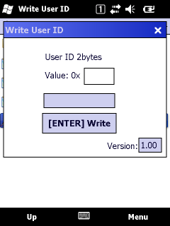
When you want to set new User ID number, you
should input 2 bytes value (4 digits number by hexadecimal number) in edit box, then press
“Write” button. Input character should be numeric
0 -9, alphabet a-f, A- F.
When you press “Write” button and if this writing
operation is success, “Complete!” message will be appeared.
When you want to terminate this tool, you should press <OK> or “x” button at right top area.

4. User ID reading method
When you want to read this setting User ID from your application program, you
should use SysGetUserIDCode function in system library.

